**Seethalakshmi Achi College for Women, Pallathur**

**Affiliated by Alagappa University**

**Department of Commerce**

**III -B.COM**

**Finance and Accounting with Zoho Books**

**HealthHub Medical Clinic**

**Team Members**

**1)L. Vaishali (Team Leader)**

**2)R. Vallikkannu**

**3)N. Vedhasri**

**4)R. Vinothini**

**Overview:**

Zoho Books is an online accounting solution specifically designed to assist small businesses in managing their finances. It provides users with customizable dashboards and a wide variety of reports while automating tasks through the creation of custom workflows.

The vendor also offers a 14-day free trial period.

Zoho Books manages your finances by keeping you GST compliant while automating business workflows and enabling collaborative work across departments. As an intelligent data-based decision-making tool, it's simple to use yet powerful enough to support growing businesses. This pioneer product from a reputable software provider eliminates worries related to uptime, support or security issues.

By using Zoho Books' features such as cash flow statements, P&L balance sheets etc., users can send professional invoices and receive online payments all from one platform. Not only does it facilitate financial control over the company's accounts but also saves money in the long run as it is relatively affordable for small-biz and mid-market-friendly customers.

**Empathy Map**:

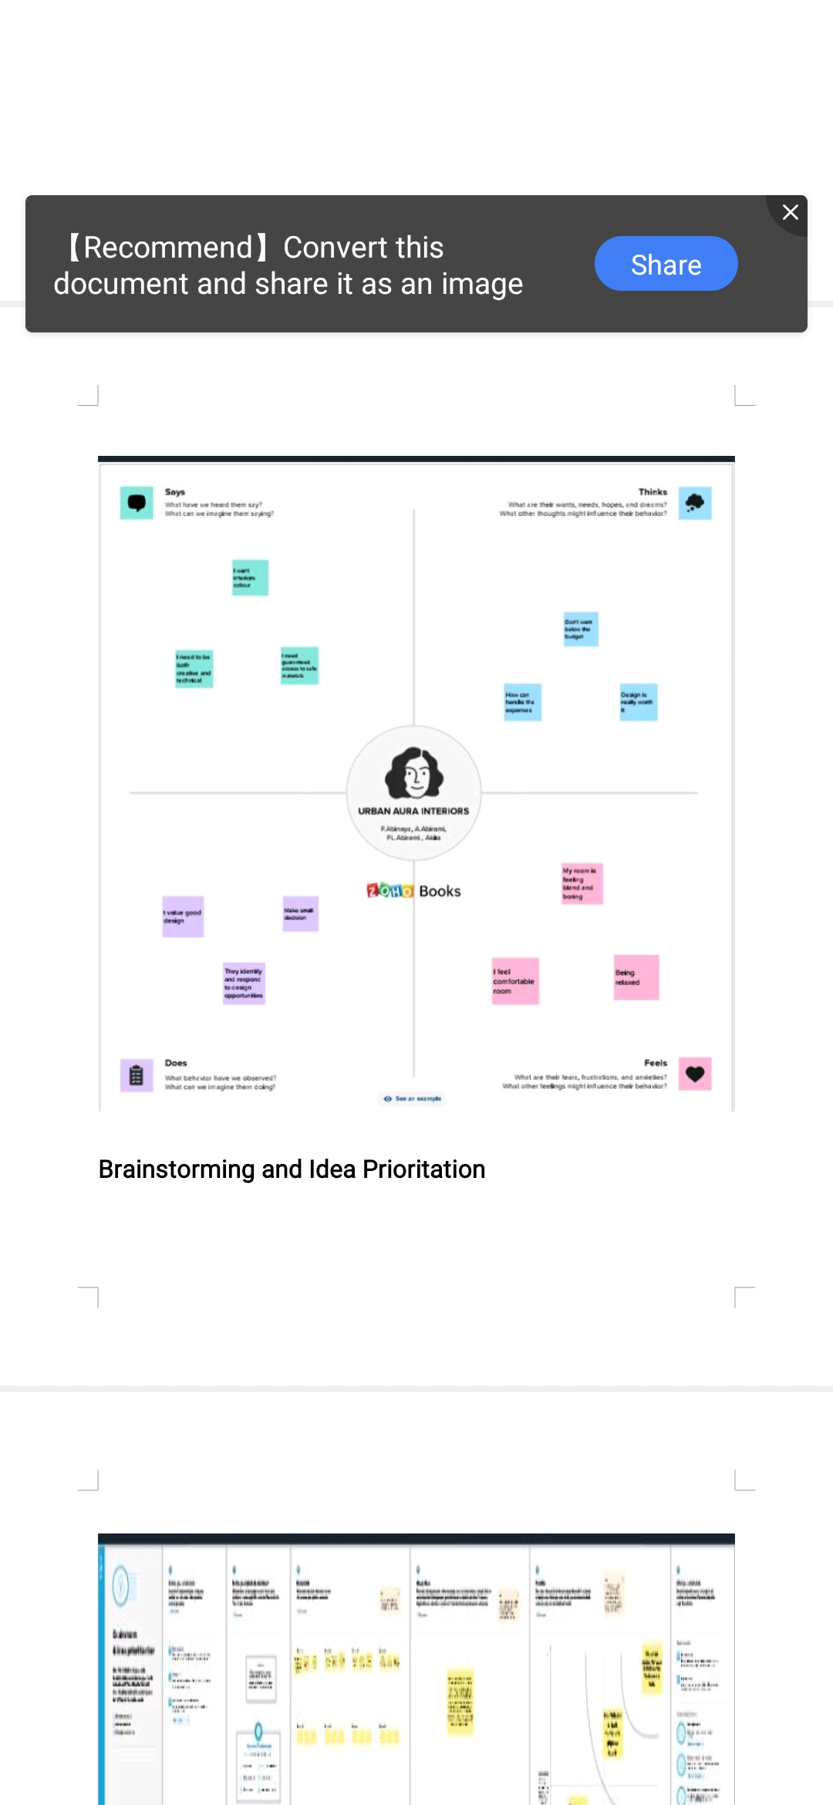

Brainstorming and Idea Prioritization: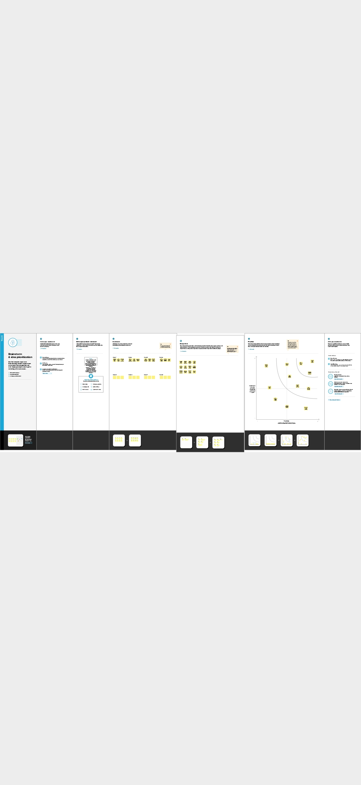

Result:

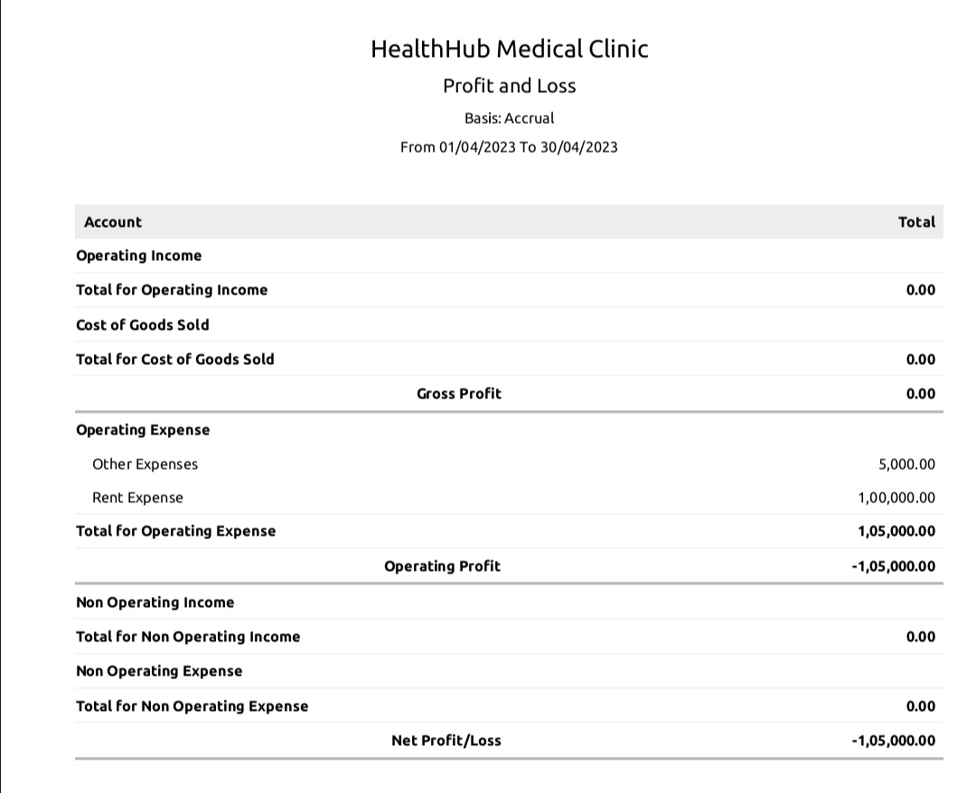

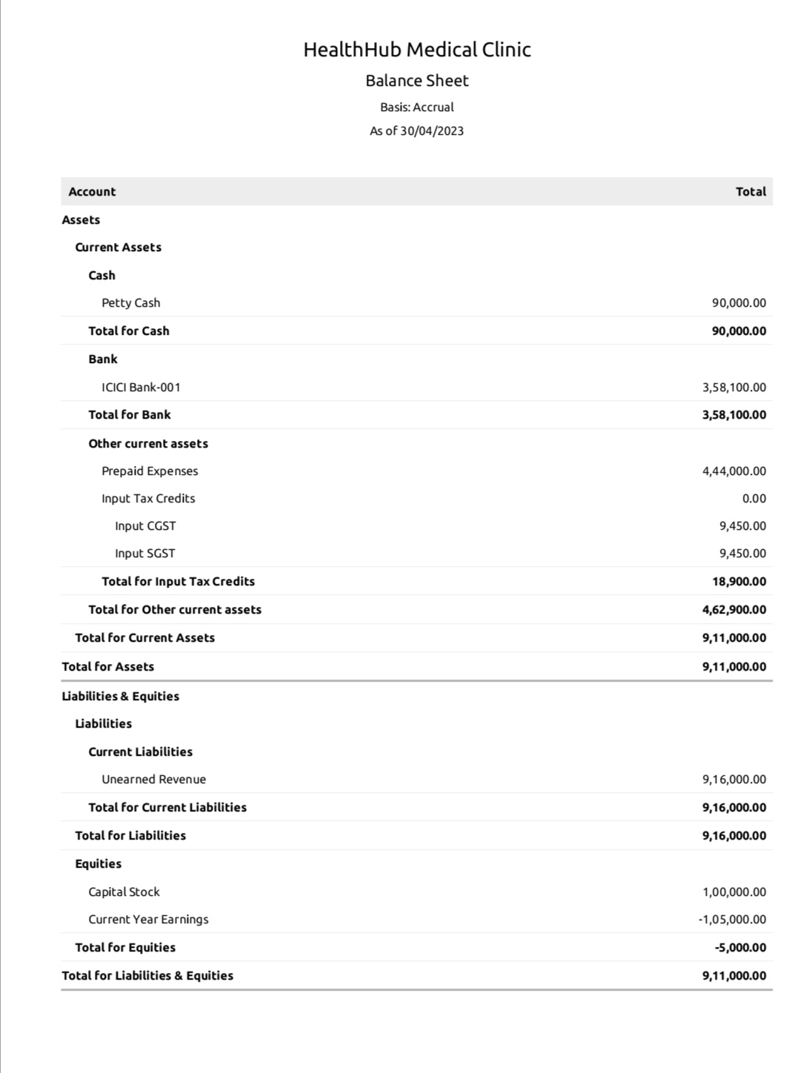

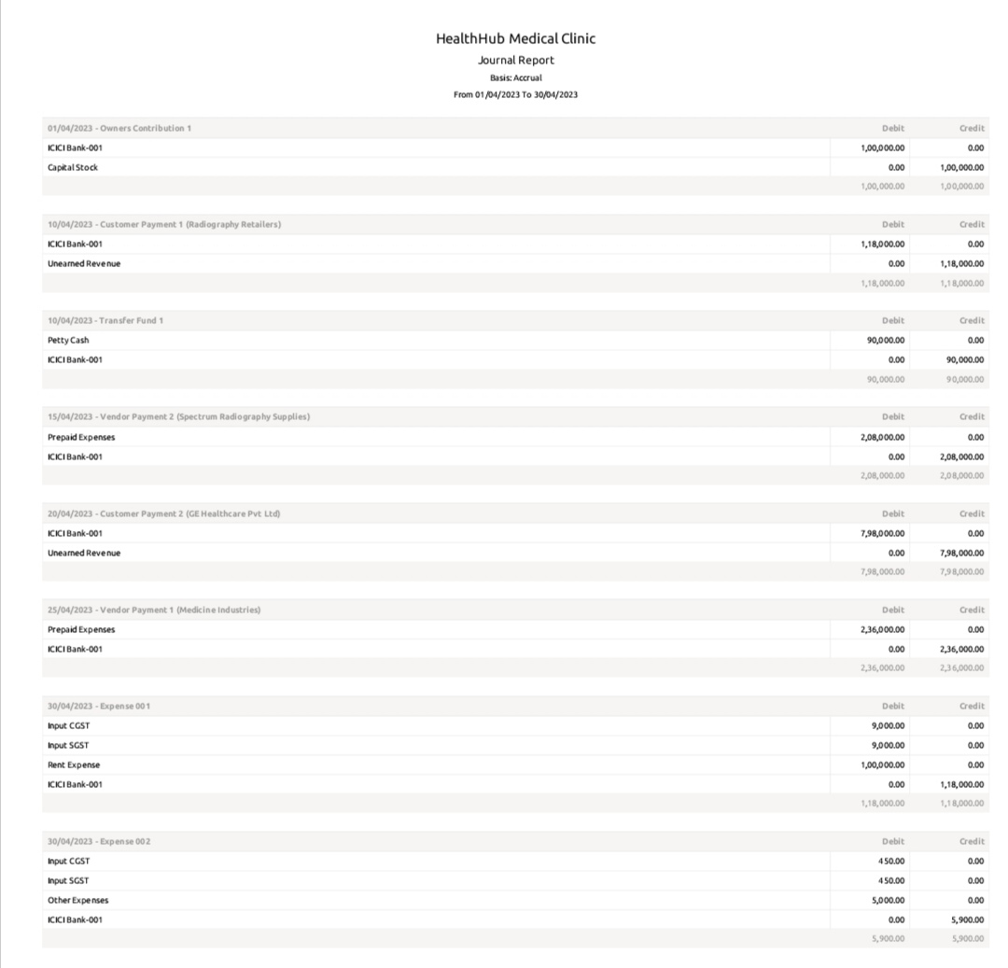

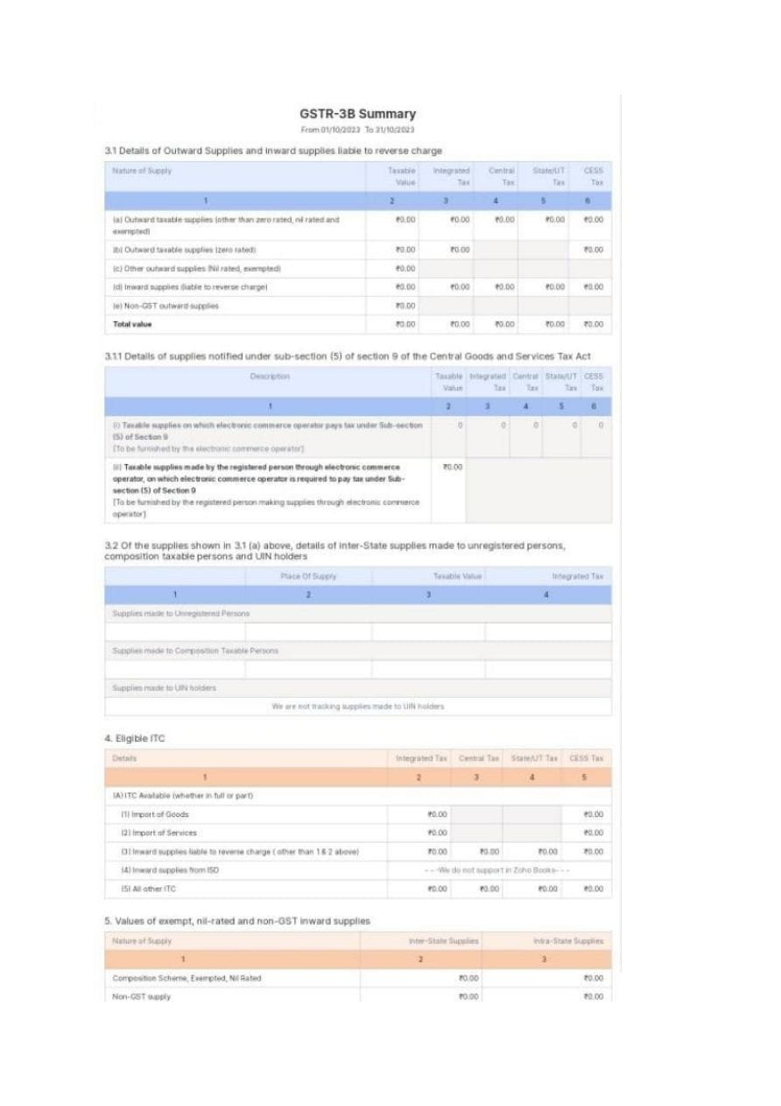

Advantages of proposed solution :

1. Invoicing & Billing.

2. Online Payment.

3. Expenses Tracking

4. Project Management & Timesheets

5. Inventory Management

6. VAT Tax compliance

7. Report Generation

8. Reduce Overall Costs.

Disadvantages of the Proposed Solition:

1. Monthly transaction cap. One significant Zoho Books limitation is the cap on monthly transaction.

2. Multiple subscriptions for Multiple businesses.

3. Additional users require a fee.

4. Fewer integrations than Competitors.

5. No Payroll Services.

6. Accounts Payable Limitations

The Areas where this solution can be applied:

Zoho Creator’s education ERP system has everything you need to completely run an educational institutions, from preschool all the way up to university. A Custom school ERP built atop Creator’s intuitive low-code application development platform is a one-stop shop for all your education management needs. From admissions to accounting, take care of everything with cloud-based applications. Build apps with minimal coding, or install prebuild ones and customize them as needed

1.Contact Management.

2.Online payments.

3.Inventory Management.

4.Mobile apps.

5.Collaborative customer portal.

6.GST Compliant Accounting.

7.Project Time Tracking.

8.Invoice Templates.

9.Automatic Bank Feeds.

10.Exhaustive Reports.

11.Accounting.

Conclusions:

Zoho Books simplifies not just streamlining invoicing processes but other business needs too including expense monitoring along with simplified Accounting procedures – filing GST returns can even be done directly with ease! Above all else though its outstanding support has been praised highly among current user base making them feel assured they're always supported regardless what may arise during normal day-to-day operations.

Future Scope:

Zoho Books now supports recurring payments via Stripe allowing acceptance recurring payments issued using Visa/MasterCard branded cards based India region although card details must first saved before transactions processed accordingly any future billings scheduled occur automatically according preset schedule determined beforehand giving greater flexibility those needing regular cashflow forecasting abilities into account when planning budgets throughout year ahead leading many consider adopting this cutting-edge technology themselves soonest possible!